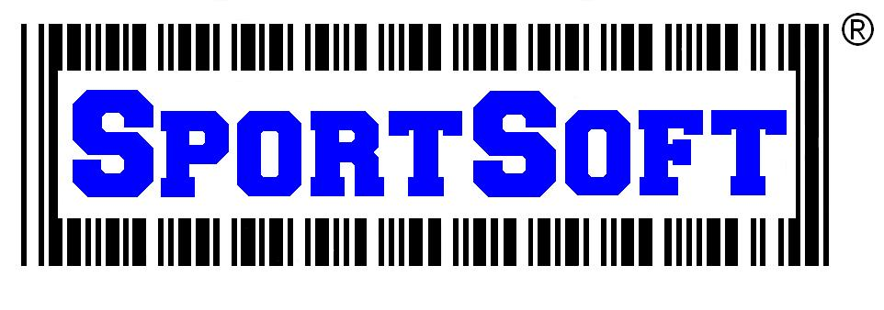

Installing Equipment Manager Trial Version:

- Install the trial version first by clicking this link: http://www.sportsoft.com/trial-version-of-equipment-manager/ . Click on ‘3. Trial version of Equipment Manager’ like the figure below:
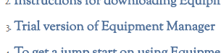
- When prompted at the bottom of the screen, click ‘Run’ or ‘Save’. This will save the file to your downloads folder.
- Navigate to the ‘downloads’ folder, open and run the file. Click on ‘Next’ until the program is fully installed.
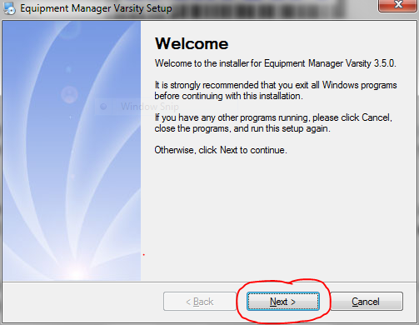
- If this a first time install, click ‘YES’ if the program asking you whether or not a NEW database should be created:
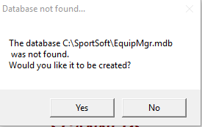

- Open the shortcut on the desktop and you can begin using the program!
Technical Questions? Contact our live technical support team at (425) 822-4613 or email us at sportsoft@sportsoft.com

